Project Report on DBMS

Pseudo Taxi

Management System

Submitted By-

Akshit Kathuria 102003126

Sanyam Singhal 102003125

Prajjwal Mehta 102003127

Deepak Bansal 102003129

Submitted To-

Ms.Sugandhi



**DEPARTMENT OF ELECTRONICS AND COMMUNICATION**

**ENGINEERING**

**THAPAR INSTITUTE OF ENGINEERING AND TECHNOLOGY,**

**(DEEMED TO BE UNIVERSITY), PATIALA, PUNJAB, INDIA**

**Jan-June 2022**

**TABLE OF CONTENTS**

|  |  |
| --- | --- |
| 1 | ER Diagram |
| 2 | Tables |
| 3 | Normalization |
| 4 | PL SQL |
| 5 | Output |
| 6 | Full Code |

Tables

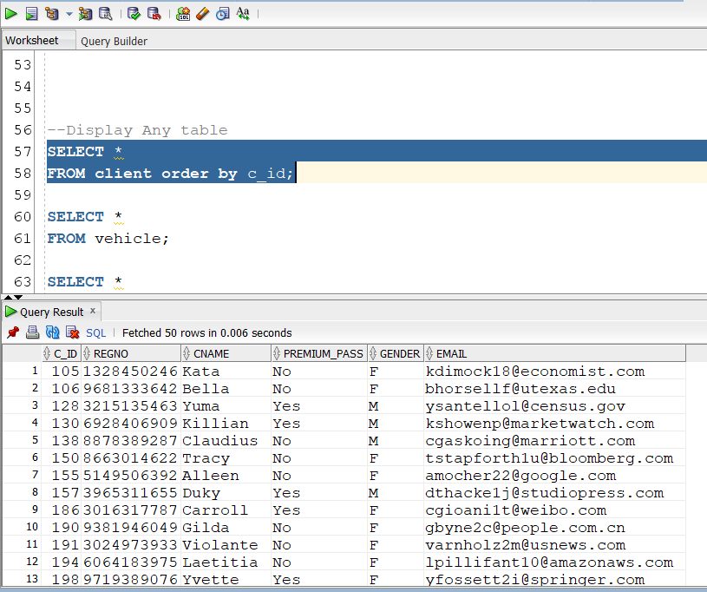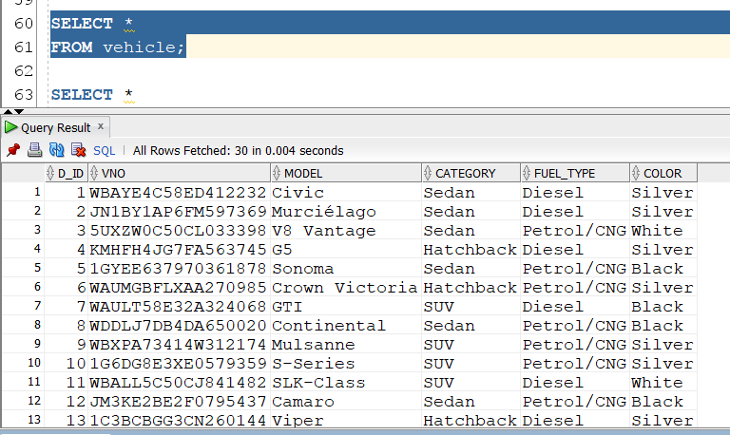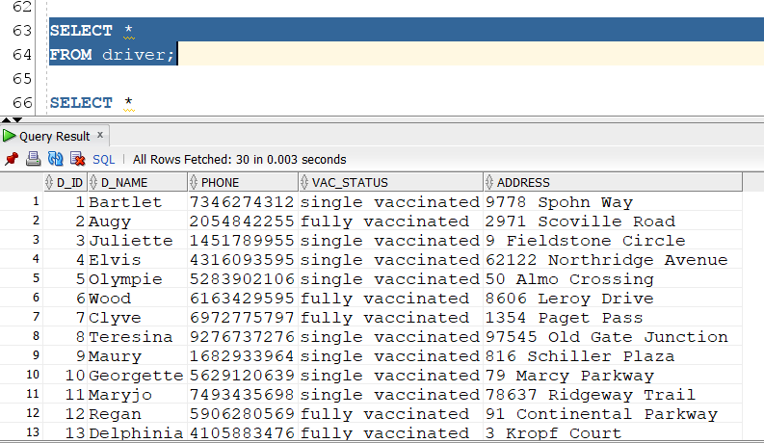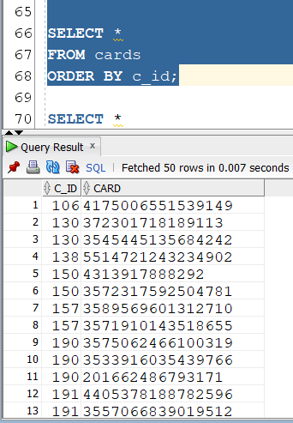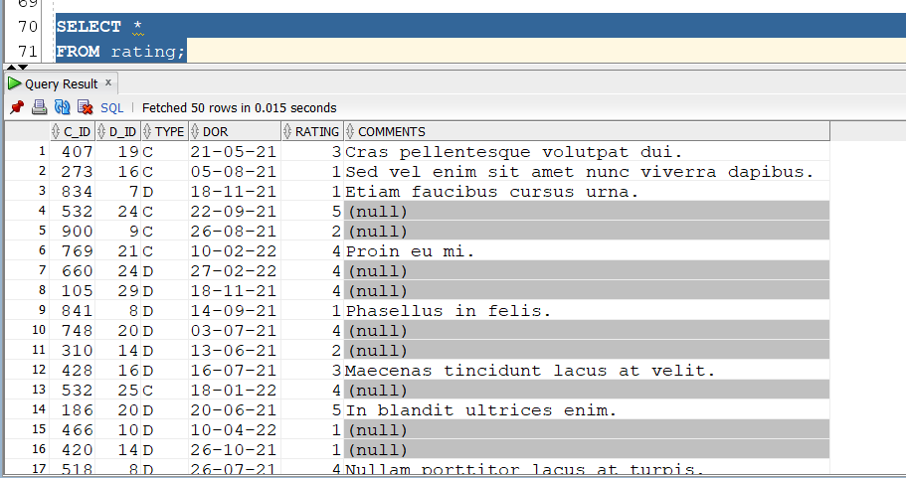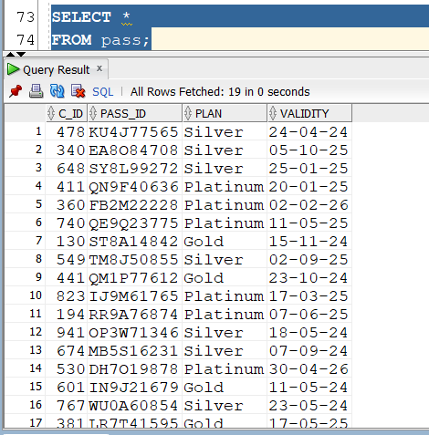

Normalization

In Table Client , Credit Card Field is Multi Values Attribute and Requires

Normalization, We used Normalization by Decomposition to make a new table cards To store multiple cards

Normalization by Flattening

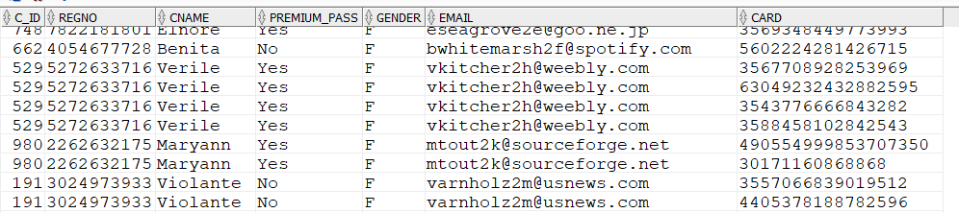

Normalization by Decomposition

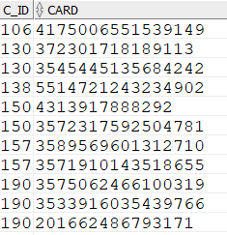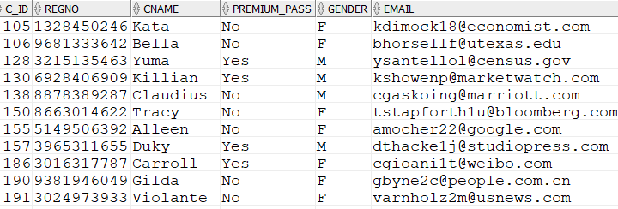

### PL SQL Code With Screenshots

**-- ****** Exception Handling \*\*\*\*\*\*\*\*\***

**--Rate a Driver Program**

DECLARE

rating_mt5 EXCEPTION;

rat NUMBER;

did NUMBER(2);

driv driver.d_name%TYPE;

BEGIN

did := &driver_id_of_driver;

--SELECT d_name INTO driv FROM driver;

SELECT d_name

INTO driv

FROM driver

WHERE d_id = did;

rat := &rating;

IF rat > 5 OR rat < 1 THEN

RAISE rating_mt5;

END IF;

dbms_output.put_line('You have Rated '

|| driv

|| ' with '

|| rat

|| ' stars');

EXCEPTION

WHEN too_many_rows THEN

dbms_output.put_line('TOO MANY ROWS');

WHEN no_data_found THEN

dbms_output.put_line('NO DATA FOUND');

WHEN rating_mt5 THEN

dbms_output.put_line('Rating can only be between 1 and 5');

WHEN OTHERS THEN

dbms_output.put_line('other errors');

END;

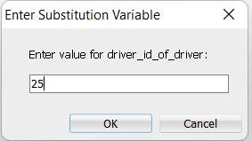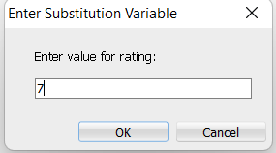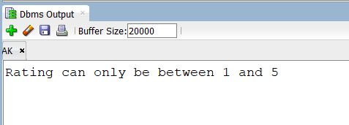

**--******Trigger\*\*\*\*\*\***

CREATE OR REPLACE TRIGGER cl_upper BEFORE

INSERT OR UPDATE OF cname ON client

FOR EACH ROW

BEGIN

:new.cname := upper(:new.cname);

END;

/

update client set cname='akshit';

select* from client;

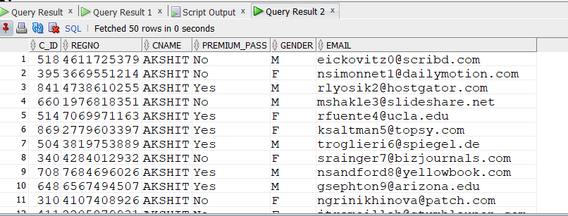

**--***Procedure \*\*\***

create or replace procedure end_prem(cid number) as

begin

delete from pass where c_id = cid;

end;

/

declare

d number;

begin

d:=478;

end_prem(d);

end;

/

select* from pass;

Before Running Above Code

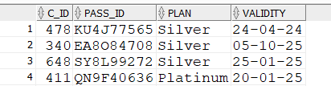

After Running

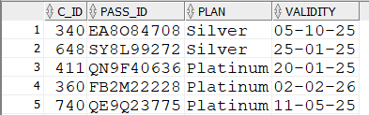

**-- *******Cursor Handling \*\*\*\*\***

DECLARE

CURSOR c1 IS

SELECT *

FROM cards

WHERE c_id = 318;

BEGIN

FOR rec IN c1 LOOP

dbms_output.put_line('CID '

|| rec.c_id

|| ' card '

|| rec.card);

END LOOP;

END;

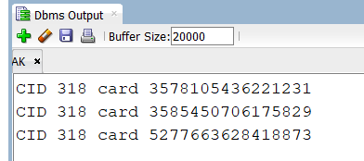

### Output Screenshots Other Queries

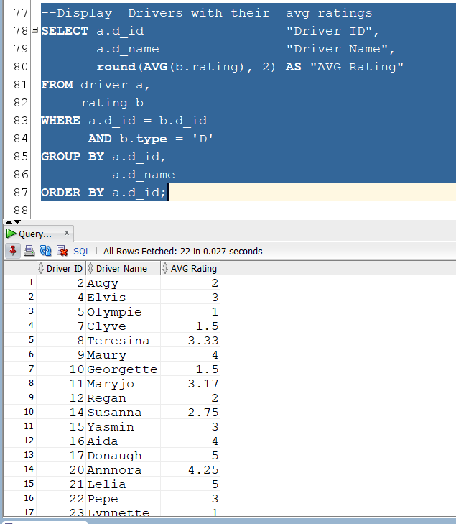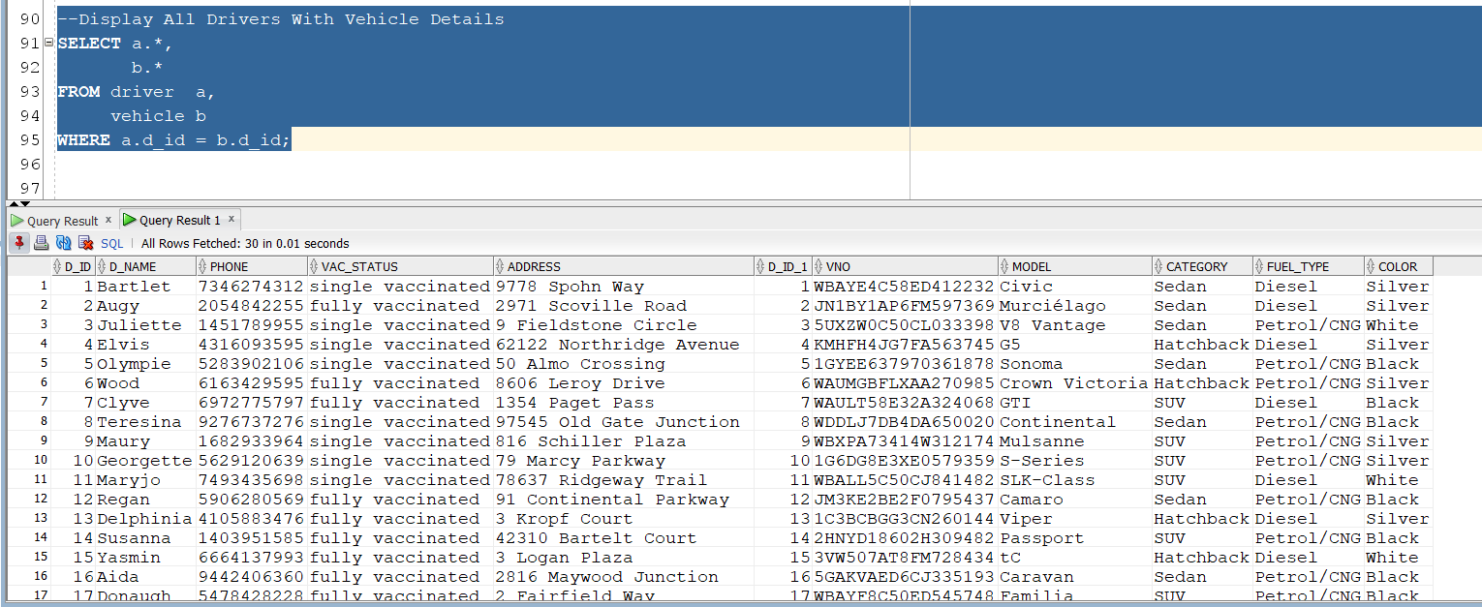

### Full Code

CREATE TABLE client (

c_id NUMBER PRIMARY KEY,

regno VARCHAR(20),

cname VARCHAR(20),

premium_pass VARCHAR(5),

gender CHAR,

email VARCHAR(30)

);

CREATE TABLE cards (

c_id NUMBER

REFERENCES client ( c_id ),

card VARCHAR(20)

);

CREATE TABLE driver (

d_id NUMBER PRIMARY KEY,

d_name VARCHAR(20),

phone VARCHAR(10),

vac_status VARCHAR(20),

address VARCHAR(30)

);

CREATE TABLE vehicle (

d_id NUMBER PRIMARY KEY

REFERENCES driver ( d_id ),

vno VARCHAR(25) UNIQUE,

model VARCHAR(20),

category VARCHAR(20),

fuel_type VARCHAR(10),

color VARCHAR(20)

);

CREATE TABLE pass (

c_id NUMBER

REFERENCES client ( c_id ),

pass_id VARCHAR(10) PRIMARY KEY,

plan VARCHAR(10),

validity DATE

);

CREATE TABLE rating (

c_id NUMBER

REFERENCES client ( c_id ),

d_id NUMBER

REFERENCES driver ( d_id ),

type CHAR,

dor DATE,

rating INT,

comments VARCHAR(50)

);

insert into client (c_id, cname, regno, premium_pass, gender, email) values (518, 'Elton', '4611725379', 'No', 'M', 'eickovitz0@scribd.com');

insert into client (c_id, cname, regno, premium_pass, gender, email) values (395, 'Nedda', '3669551214', 'No', 'F', 'nsimonnet1@dailymotion.com');

insert into client (c_id, cname, regno, premium_pass, gender, email) values (841, 'Roma', '4738610255', 'Yes', 'M', 'rlyosik2@hostgator.com');

insert into client (c_id, cname, regno, premium_pass, gender, email) values (660, 'Meier', '1976818351', 'No', 'M', 'mshakle3@slideshare.net');

insert into client (c_id, cname, regno, premium_pass, gender, email) values (514, 'Roanne', '7069971163', 'Yes', 'F', 'rfuente4@ucla.edu');

insert into client (c_id, cname, regno, premium_pass, gender, email) values (869, 'Kerrin', '2779603397', 'Yes', 'F', 'ksaltman5@topsy.com');

insert into client (c_id, cname, regno, premium_pass, gender, email) values (504, 'Tiebout', '3819753889', 'Yes', 'M', 'troglieri6@spiegel.de');

insert into client (c_id, cname, regno, premium_pass, gender, email) values (340, 'Sharia', '4284012932', 'No', 'F', 'srainger7@bizjournals.com');

insert into client (c_id, cname, regno, premium_pass, gender, email) values (708, 'Niko', '7684696026', 'Yes', 'M', 'nsandford8@yellowbook.com');

insert into client (c_id, cname, regno, premium_pass, gender, email) values (648, 'Gasper', '6567494507', 'Yes', 'M', 'gsephton9@arizona.edu');

insert into client (c_id, cname, regno, premium_pass, gender, email) values (310, 'Nannette', '4107408926', 'No', 'F', 'ngrinikhinova@patch.com');

insert into client (c_id, cname, regno, premium_pass, gender, email) values (411, 'Jannel', '2205879931', 'No', 'F', 'jtremoilleb@stumbleupon.com');

insert into client (c_id, cname, regno, premium_pass, gender, email) values (360, 'Kellia', '9546271574', 'Yes', 'F', 'kgoric@apache.org');

insert into client (c_id, cname, regno, premium_pass, gender, email) values (740, 'Letisha', '3703661736', 'No', 'F', 'lhoytd@soup.io');

insert into client (c_id, cname, regno, premium_pass, gender, email) values (273, 'Stevy', '8133684552', 'No', 'M', ['scosgrovee@cbsnews.com');](mailto:'scosgrovee@cbsnews.com');)

insert into cards (c_id, card) values (360, '4936828317835077');

insert into cards (c_id, card) values (771, '5405358479701809');

insert into cards (c_id, card) values (530, '6334033742445591');

insert into cards (c_id, card) values (478, '5602215920657538');

insert into cards (c_id, card) values (441, '633338943922426129');

insert into cards (c_id, card) values (190, '3533916035439766');

insert into cards (c_id, card) values (557, '56022518209266110');

insert into cards (c_id, card) values (504, '5569702618539509');

insert into cards (c_id, card) values (514, '3582968595835347');

insert into cards (c_id, card) values (130, '3545445135684242');

insert into cards (c_id, card) values (138, '5514721243234902');

insert into driver (d_id, d_name, phone, vac_status, address) values (1, 'Bartlet', '7346274312', 'single vaccinated', '9778 Spohn Way');

insert into driver (d_id, d_name, phone, vac_status, address) values (2, 'Augy', '2054842255', 'fully vaccinated', '2971 Scoville Road');

insert into driver (d_id, d_name, phone, vac_status, address) values (3, 'Juliette', '1451789955', 'single vaccinated', '9 Fieldstone Circle');

insert into driver (d_id, d_name, phone, vac_status, address) values (4, 'Elvis', '4316093595', 'single vaccinated', '62122 Northridge Avenue');

insert into driver (d_id, d_name, phone, vac_status, address) values (5, 'Olympie', '5283902106', 'single vaccinated', '50 Almo Crossing');

insert into pass (c_id, pass_id, plan, validity) values (478, 'KU4J77565', 'Silver', '24-Apr-2024');

insert into pass (c_id, pass_id, plan, validity) values (340, 'EA8O84708', 'Silver', '05-Oct-2025');

insert into pass (c_id, pass_id, plan, validity) values (648, 'SY8L99272', 'Silver', '25-Jan-2025');

insert into pass (c_id, pass_id, plan, validity) values (411, 'QN9F40636', 'Platinum', '20-Jan-2025');

insert into pass (c_id, pass_id, plan, validity) values (360, 'FB2M22228', 'Platinum', '02-Feb-2026');

insert into pass (c_id, pass_id, plan, validity) values (740, 'QE9Q23775', 'Platinum', '11-May-2025');

insert into pass (c_id, pass_id, plan, validity) values (130, 'ST8A14842', 'Gold', '15-Nov-2024');

insert into pass (c_id, pass_id, plan, validity) values (549, 'TM8J50855', 'Silver', '02-Sep-2025');

insert into pass (c_id, pass_id, plan, validity) values (441, 'QM1P77612', 'Gold', '23-Oct-2024');

insert into pass (c_id, pass_id, plan, validity) values (823, 'IJ9M61765', 'Platinum', '17-Mar-2025');

insert into pass (c_id, pass_id, plan, validity) values (194,

insert into rating (c_id, d_id, type, dor, rating, comments) values (407, 19, 'C', '21-May-2021', 3, 'Cras pellentesque volutpat dui.');

insert into rating (c_id, d_id, type, dor, rating, comments) values (273, 16, 'C', '05-Aug-2021', 1, 'Sed vel enim sit amet nunc viverra dapibus.');

insert into rating (c_id, d_id, type, dor, rating, comments) values (834, 7, 'D', '18-Nov-2021', 1, 'Etiam faucibus cursus urna.');

insert into rating (c_id, d_id, type, dor, rating, comments) values (532, 24, 'C', '22-Sep-2021', 5, null);

insert into rating (c_id, d_id, type, dor, rating, comments) values (900, 9, 'C', '26-Aug-2021', 2, null);

insert into rating (c_id, d_id, type, dor, rating, comments) values (769, 21, 'C', '10-Feb-2022', 4, 'Proin eu mi.');

insert into rating (c_id, d_id, type, dor, rating, comments) values (660, 24, 'D', '27-Feb-2022', 4, null);

insert into rating (c_id, d_id, type, dor, rating, comments) values (105, 29, 'D', '18-Nov-2021', 4, null);

insert into rating (c_id, d_id, type, dor, rating, comments) values (841, 8, 'D', '14-Sep-2021', 1, 'Phasellus in felis.');

insert into rating (c_id, d_id, type, dor, rating, comments) values (748, 20, 'D', '03-Jul-2021', 4, null);

insert into vehicle (d_id, vno, model, category, fuel_type, color) values (1, 'WBAYE4C58ED412232', 'Civic', 'Sedan', 'Diesel', 'Silver');

insert into vehicle (d_id, vno, model, category, fuel_type, color) values (2, 'JN1BY1AP6FM597369', 'MurciÃ©lago', 'Sedan', 'Diesel', 'Silver');

insert into vehicle (d_id, vno, model, category, fuel_type, color) values (3, '5UXZW0C50CL033398', 'V8 Vantage', 'Sedan', 'Petrol/CNG', 'White');

insert into vehicle (d_id, vno, model, category, fuel_type, color) values (4, 'KMHFH4JG7FA563745', 'G5', 'Hatchback', 'Diesel', 'Silver');

insert into vehicle (d_id, vno, model, category, fuel_type, color) values (5, '1GYEE637970361878', 'Sonoma', 'Sedan', 'Petrol/CNG', 'Black');

--Display Any table

SELECT *

FROM client order by c_id;

SELECT *

FROM vehicle;

SELECT *

FROM driver;

SELECT *

FROM cards

ORDER BY c_id;

SELECT *

FROM rating;

SELECT *

FROM pass;

--Display Drivers with their avg ratings

SELECT a.d_id "Driver ID",

a.d_name "Driver Name",

round(AVG(b.rating), 2) AS "AVG Rating"

FROM driver a,

rating b

WHERE a.d_id = b.d_id

AND b.type = 'D'

GROUP BY a.d_id,

a.d_name

ORDER BY a.d_id;

--Display All Drivers With Vehicle Details

SELECT a.*,

b.*

FROM driver a,

vehicle b

WHERE a.d_id = b.d_id;

-- ****** Exception Handling *********

--Rate a Driver Program

DECLARE

rating_mt5 EXCEPTION;

rat NUMBER;

did NUMBER(2);

driv driver.d_name%TYPE;

BEGIN

did := &driver_id_of_driver;

--SELECT d_name INTO driv FROM driver;

SELECT d_name

INTO driv

FROM driver

WHERE d_id = did;

rat := &rating;

IF rat > 5 OR rat < 1 THEN

RAISE rating_mt5;

END IF;

dbms_output.put_line('You have Rated '

|| driv

|| ' with '

|| rat

|| ' stars');

EXCEPTION

WHEN too_many_rows THEN

dbms_output.put_line('TOO MANY ROWS');

WHEN no_data_found THEN

dbms_output.put_line('NO DATA FOUND');

WHEN rating_mt5 THEN

dbms_output.put_line('Rating can only be between 1 and 5');

WHEN OTHERS THEN

dbms_output.put_line('other errors');

END;

-- *******Cursor Handling *****

DECLARE

CURSOR c1 IS

SELECT *

FROM cards

WHERE c_id = 318;

BEGIN

FOR rec IN c1 LOOP

dbms_output.put_line('CID '

|| rec.c_id

|| ' card '

|| rec.card);

END LOOP;

END;

--******Trigger******

CREATE OR REPLACE TRIGGER cl_upper BEFORE

INSERT OR UPDATE OF cname ON client

FOR EACH ROW

BEGIN

:new.cname := upper(:new.cname);

END;

/

update client set cname='akshit';

select* from client;

--***Procedure ***

create or replace procedure end_prem(cid number) as

begin

delete from pass where c_id = cid;

end;

/

declare

d number;

begin

d:=478;

end_prem(d);

end;

/

select* from pass;